Lab 5: Image Segmentation through K-Means

The goal of image segmentation is to partition an image into regions, each of which have a resonably homogenous visual appearance or which corresponds to similar objects or parts of an object. Each pixel in an image is a point in a 3-dimensional space comprising of the intensities of the red, blue, and green channels, and our segmentation algorithm simply treats each pixel in the image as a separate data point. We illustrate the result of running Kmeans, for any particular value of K, by re-drawing the image replacing each pixel vector with the (R,G,B} intensity triplet given by the centroid to with that pixel has been assigned. Results for various values of K based on example elephant.jpg are shown as follow.

You have two images — elephant.jpg and eiffel.jpg, on which you will be running your K-Means code.

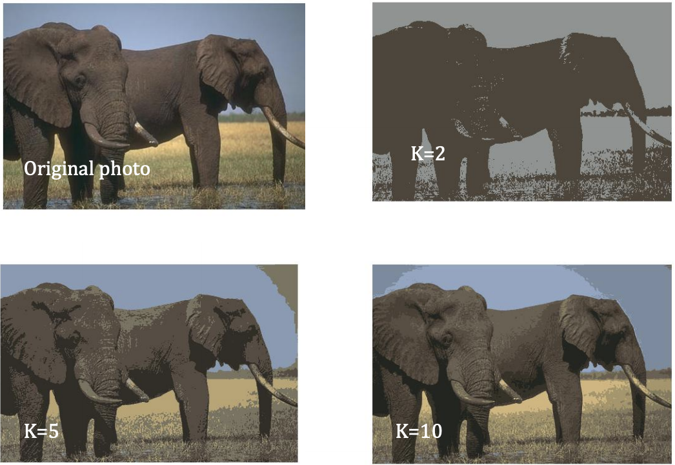

Figure 1. Segmentation of the image into different segments based on K-Means algorithm

**K-Means Implementation**

**Step 1: K-Means Algorithm**

Write your code in the file "KMeans.m" included in the folder. Your *KMeans*(Image,K,maxIter) function takes in 3 inputs — **1) Image**, to run K-Means segmentation on, **2) K**, denoting the number of segments you wish to classify the pixels of the image image into, **3) maxIter**, specifying the upper bound on the number of iterations before the code terminates. The *KMeans* function should ouput the following — 1) final set of coordinates of the K centroids, 2) final segmented image based on the K centroids.

[centroid_coord, segmented_image] = KMeans(Image,K,maxIter);

**Step 2: Testing**

Load elephant.jpg and eiffel.jpg images and run K-Means, with K = 2, K = 5 and K = 10 on both the images. Generate ***two*** figures, for elephant and eiffel images, with each figure having 4 subplots with the original image and segmented images (see Fig. 1).

**Step 3: Comparison with MATLAB K-Means**

Now use the inbuilt MATLAB *kmeans* function and compare the output for the elephant.jpg image **only.** You code should generate ***one*** figure with the original image, segmented image from your K-Means code with K = 5, segmented image from the MATLAB K-Means function with K = 5.

**Step 4: Code Optimization (Optional)**

Generate the times it takes to run your K-Means and the MATLAB K-Means function with K = 5 on the elephant image. **Print** the runtimes. Try optimizing ***your*** K-Meanscode to generate the segmented image within the order of a few seconds, in comparison to the MATLAB K-Means computation times.